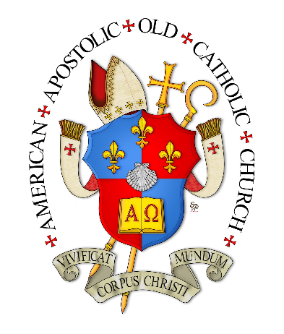 | St. Aelred’s Seminary:  The Minor Prophets  Spring 2020  The Most Rev. Dr. Joseph C. Richards, AAOCC  Email: richardsAAOCC@gmail.com  Phone: 330.842.7417

Class: Lecture on Friday 7:00-8:30 p.m. EST

- COURSE DESCRIPTION AND OBJECTIVES

- To understand how the minor prophets had a major impact on the Jewish experience
- How did they fit within the greater historical context of the Hebrew Scriptures
- To see the close interaction of the prophets and the local congregations, synagogues and temples.
- To understand the message they brought to the table and the results
- To explore hermeneutic and exegetical questions related to each prophet

- COURSE TEXTS

The Holy Bible, New International Version. (2011). Grand Rapids: Zondervan
Publishing House.

Optional but recommended:
Wiersbe, Warren W. Old Testament Commentary: Minor Prophets. Series (6 books). Colorado Springs: David Cook Pub. (paperback)

- COURSE STRUCTURE

- Just as the Catholic Letters of the New Testament are often overlooked or dismissed as homiletic subject matter, so to the Minor Prophets are quite unknown to the average Christian. They provide essential pieces to the narrative that form salvation history.
- It will seem strange at first, but we will be addressing the Hebrew Scriptures from the last book of the prophets proceeding backward in time. The reasons will become clear as we go further into the course.
- Lecture Agenda:
- Recorded NIV reading
- Biography of the Prophet
- Structure of the Book
- Geography
- Discussion of the questions prepared for the week
- Questions will be posted the week prior to the discussion of the Prophet, so that some measure of familiarity with the material will serve us during class.
- COURSE REQUIREMENTS

- Final Paper (50 points) – To write an exegetical paper on one of the Minor Prophets – choosing a book, chapter, pericope or verses. All principles of hermeneutical study should be employed, including but not limited to: context; genre; structure; canonicity; placement; message; delivery; word study; commentary, etc.

- The paper must be between 7-10 pages in length with at least three to five academic sources. (No Wikipedia). It will follow APA style format which can be accessed at https://owl.english.purdue.edu/owl/section/2/10/. All Seminary plagiarism rules apply.

- Topic selections must be submitted in writing & approved before 6 March

- Final Paper Due 1 May by 5 p.m.

- Content (40 points)
- Discernable Thesis Statement (5 points)
- Cohesive Argument & Comprehensive Presentation (25 points)
- Personal Reflection (5 points)
- Acceptable References (5 points)

- Style (10 points)
- Grammar (5 points)
- APA formatting (5 points)

B Reflection Papers (48 points) – Each week a set of questions will be posted. Select two questions to reflect upon. Explain your answer thoroughly and find one source of information where a scholar has spoken to your answer (include the citation). Keep answers concise; no more than two pages.

13 sets of questions x 4 points per week = 52 – one assignment = 48 points
You may select one week to skip an assignment or to have your lowest grade
dropped.

- Active participation (2 points) in discussions is crucial to full understanding of this subject. Please ask your questions.

- GRADING SCALE

94-100 points | A | 74-76 | C
90-93 | A- | 70-73 | C-
87-89 | B+ | 67-69 | D+
84-86 | B | 64-66 | D
80-83 | B- | 60-63 | D-
77-79 | C+ | Below 60 | F

VI. EXPECTATIONS

- Attendance is mandatory unless there is an emergency or prior arrangements are made with the instructor.

Lectures:

- Lectures shall be prepared for Friday’s class sessions. The Powerpoint slides should be printed in the format of you choosing to take notes on Friday’s lecture.

- Ask your questions on the lectures – have one or two prepared.

- After Final Paper topics are approved, we will discuss together what your plans are and how we can help one another with resources or ideas. Be prepared to share the resources you have picked out and the thesis statement of your paper.
Contact with the instructor. If at all possible please contact me by e-mail. I check it several times per day and prefer this type of communication.

If you need to call, please respect that this is my personal time and would appreciate it if you would only call between 10 a.m. and 10 p.m.

Projected Schedule

Date | Lecture Topic | Questions Posted for:
7 February | Introduction | Malachi
14 February | Malachi | Zechariah, Part I
21 February | Zechariah, Part I, Books 1-8 | Zechariah, Part II
28 February | Zechariah, Part II, Books 9-14 | Haggai & Zephaniah
 |  | Topic Due next class
6 March | Haggai & Zephaniah | Habakkuk & Nahum
13 March | Habakkuk & Nahum | Micah
20 March | Micah | Jonah
27 March | Jonah | Obadiah & Amos
3 April | Obadiah & Amos | Joel
10 April | No Class
17 April | Joel | Hosea
24 April | Hosea
1 May | No Class | Paper Due by 5 pm

